**Linux file system structure**

1. Open a terminal window.

2. Use the **ls** command to list the contents of directories:

* **ls** by itself lists the contents of the current directory.
* **ls** /path/to/directory lists the contents of a specific directory.
* **ls -l** provides a detailed listing, including file permissions and timestamps.
* **ls -a** shows all files, including hidden files (those starting with a dot).
* When combined, **ls -a -l** displays a detailed list of all files and directories, including hidden ones, in the current directory.

Some key directories and their purposes:

- Root directory (/):

* The top-level directory of the file system.
* Contains all other directories and files.
* Common contents:
  + bin: Essential system binaries (commands).
  + boot: Boot loader files and kernel configuration.
  + dev: Device files representing hardware components.
  + etc: System-wide configuration files.
  + home: User home directories (one for each user).
  + lib: Shared libraries for programs.
  + media: Mount points for removable media (e.g., USB drives).
  + mnt: Temporary mount points for external file systems.
  + opt: Optional software packages.
  + proc: Virtual file system providing information about processes.
  + root: Home directory of the root user.
  + sbin: System administration binaries.
  + sys: Virtual file system providing information about system devices and kernel modules.
  + tmp: Temporary files.
  + usr: Secondary hierarchy for user-related programs and data.
  + var: Variable data files, such as logs and databases.

- User home directory (~):

* The default directory for a specific user.
* Contains personal files and settings.
* Common contents:
  + Documents: Documents and text files.
  + Downloads: Downloaded files.
  + Pictures: Image files.
  + Music: Audio files.
  + Videos: Video files.
  + Desktop: Files on the user's desktop.

Note:

* Use **cd** to navigate between directories.
* Use **pwd** to display the current working directory.
* Use **man ls** to explore more options for the ls command.

Now, lets see some screenshots of the **ls** commands for the output:

Here, **ls** command is used which has listed the content of the directory.

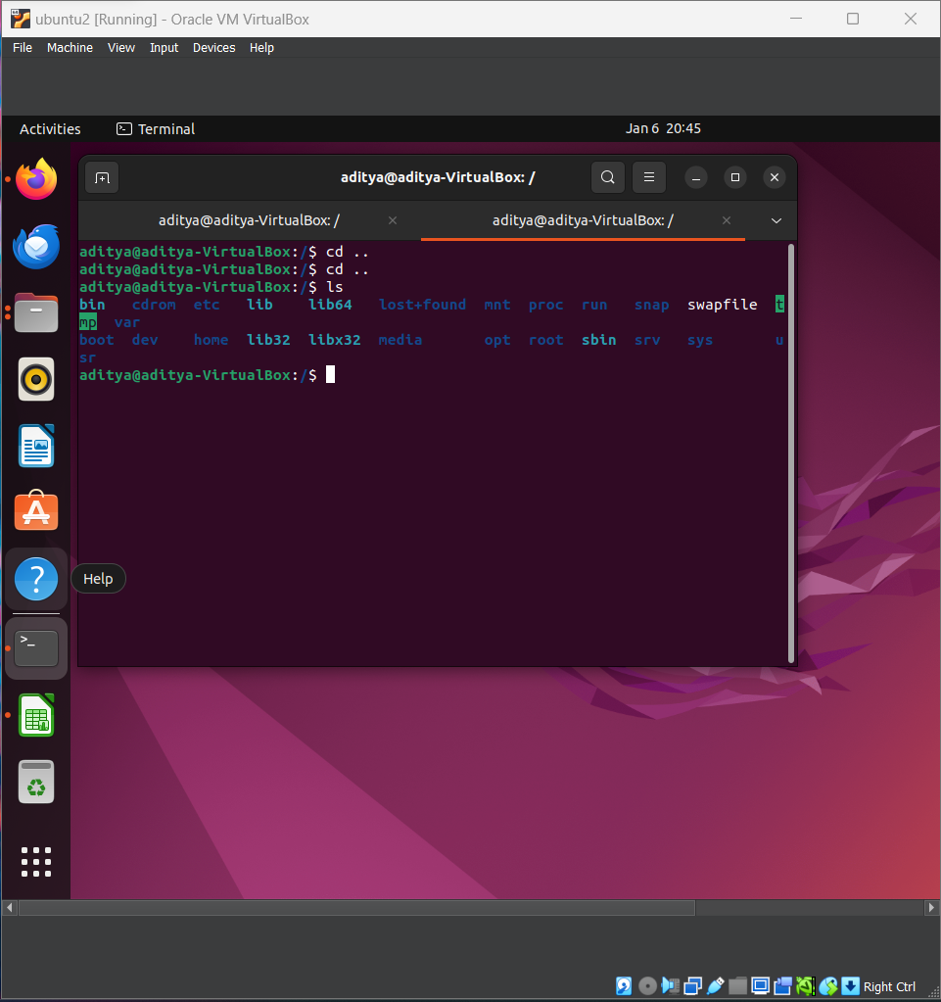

In the following picture, **ls -l** command is used which is showing a detailed listing, including file permissions and timestamps.

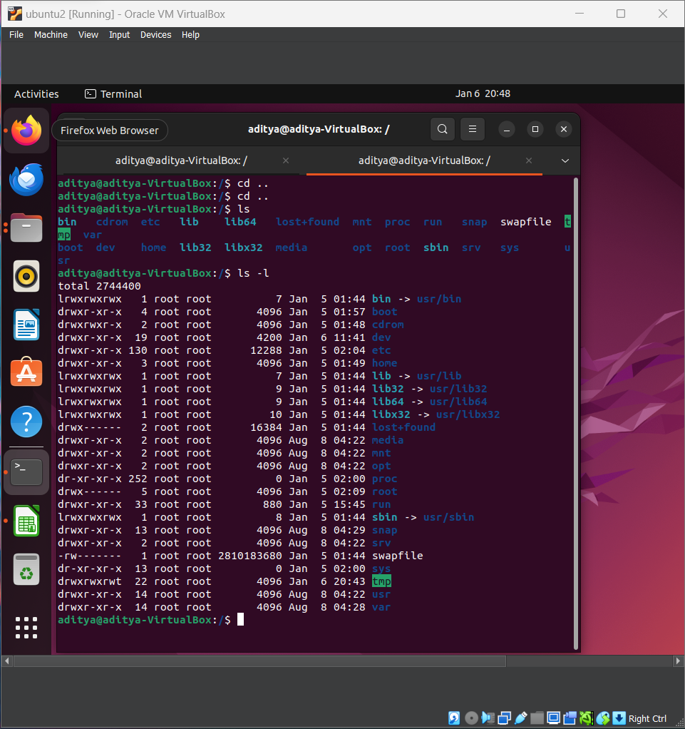

In the following image, **ls -a -l** command is used which is displaying a detailed list of all files and directories, including hidden ones, in the current directory.

